**Machine Problem 2: Python**

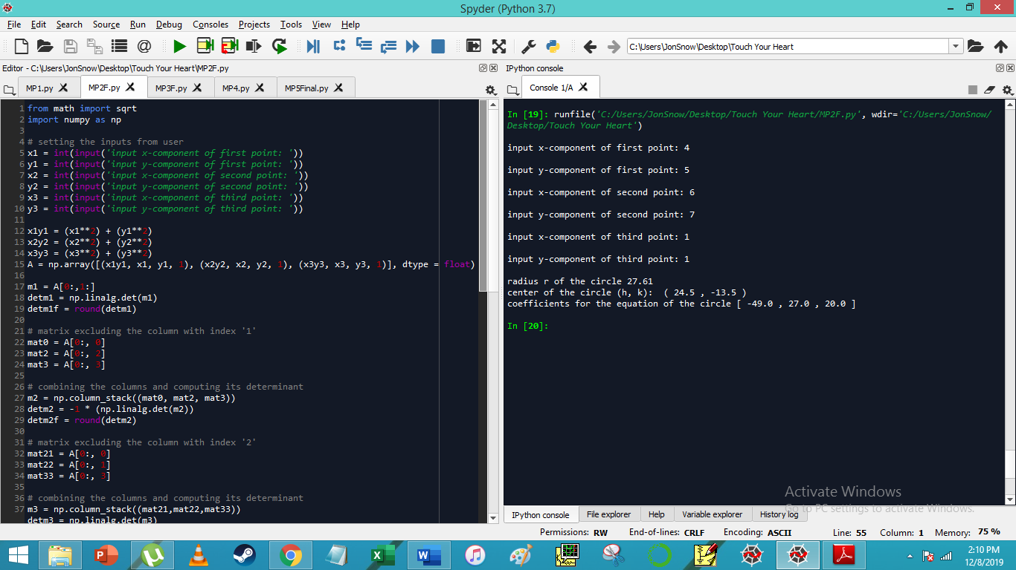

Output:

